**Assignment 1 by script**

**Script** –

pipeline {

agent{

label{

label 'built-in'

customWorkspace'/mnt/pipeline-1'

}

}

stages{

stage('one'){

steps{

git branch: 'main' , url: "https://github.com/prasadpawar252/jenkinsfile.git"

sh 'yum install httpd -y'

sh 'service httpd start'

sh 'cp /mnt/pipeline-1/index.html /var/www/html/'

sh 'chmod -R 777 /var/www/html/index.html'

}

}

}

}

**2) If want to schedule cron job** –

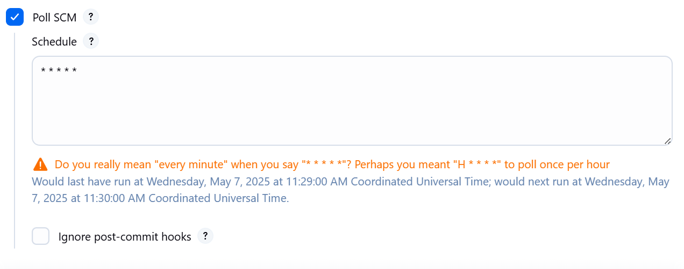

**3)Git Repo –**

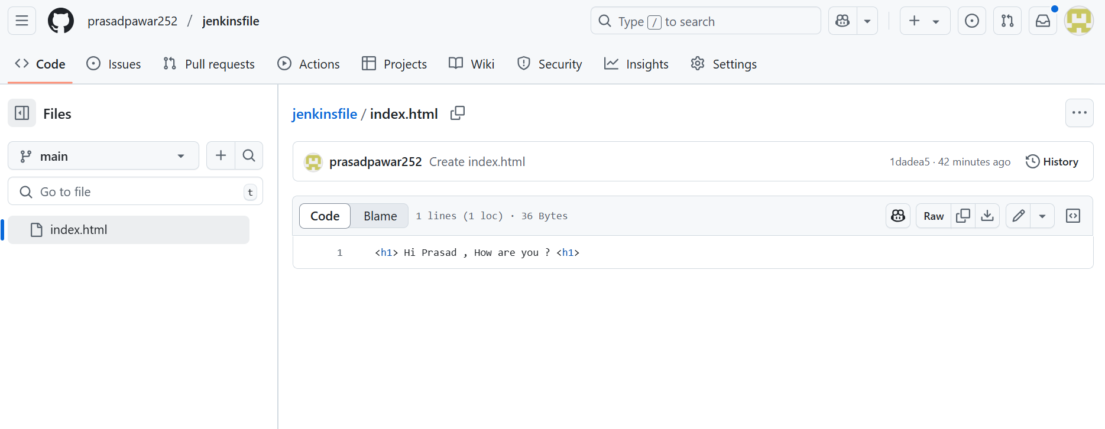

**4) Final Output –**



**5)Console Outputs –**

